Circuits Laboratory Data

Summary
We did an in-class demonstration laboratory experiment in circuits on October 14, 2009 where we:
- Introduced the basics of circuit components, voltage and current.
- Discussed Kirchhoff’s Laws and using them to write a set of simultaneous “loop” equations that describe circuit behavior.
- Used a matrix formulation of those equations and the inverse matrix to produce a solution (with MatLab in class).
- Measured resistances, node voltages and loop currents of the real circuit.

Circuit Schematic Diagram

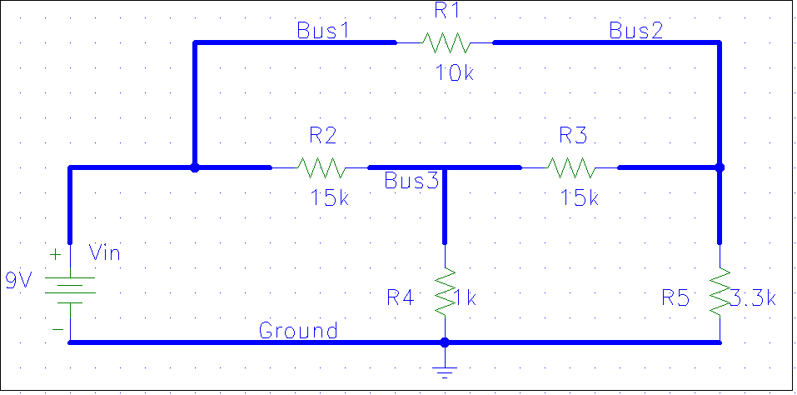
I₁
I₃
I₂
V_{a}
V_{b}

Data
The data found by using the digital volt-ohm meter was:
Designator | Nominal Value | Measured Value
V_{in} | 9 volts | 8.77 volts
R₁ | 10 kΩ | 9.87 kΩ
R₂ | 15 kΩ | 17.15 kΩ
R₃ | 15 kΩ | 14.83 kΩ
R₄ | 1 kΩ | 0.990 kΩ
R₅ | 3.3 kΩ | 3.26 kΩ
V_{a} | 0.6475 volts | 0.568 volts
V_{b} | 2.0080 volts | 1.936 volts
I₁ | 1.256 mA | 1.15 mA
I₂ | 0.6992 mA | 0.68 mA
I₃ | 0.6085 mA | 0.58 mA
Note: The current readings are less accurate than the voltage readings.
You need to compute node voltages (from the computed loop current using the measured resistances and battery voltage) to make accurate comparisons to the measured values.

